WELCOME TO THE
“CODIS PARTS CONNECTION”

The “CODIS Parts Connection” provides you, our valued customer, interactive access to CODIS’ extensive inventory of products for the lawn and garden industry. You have access from 5 a.m. till 11 p.m., 7 days a week, 52 weeks a year. Access allows you to place orders, check stock and pricing, inquire on orders and inquire on backorders. The “CODIS Parts Connection” is completely interactive and information is real-time.

In the pages to follow you will find simple, easy to understand instructions on using your new “CODIS Parts Connection”.

What’s required?
- A personal computer
- An Internet connection

CODIS provides the rest! Now, let’s get started.

When you are connected to “CODIS Parts Connection”, your screen will look like this:

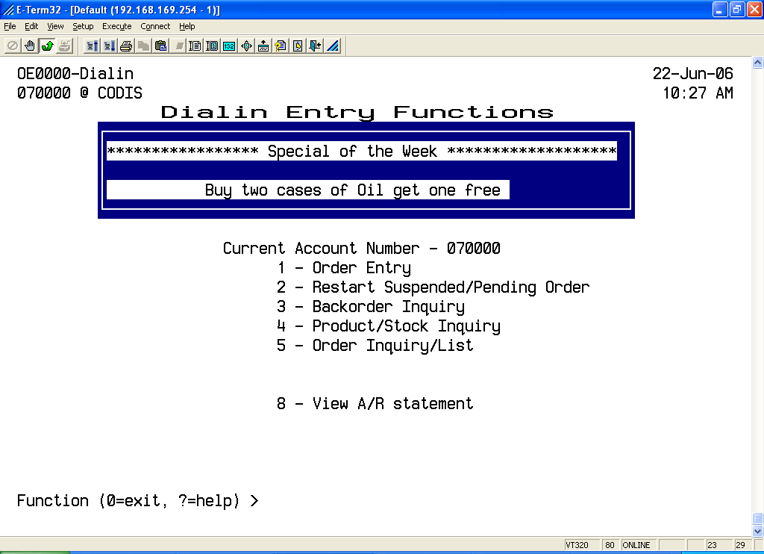

**Notice your CODIS account number appears under the menu title bar.**

1 – Order Entry (option # 1 on the Dialin Entry Functions menu)
This is where you enter orders.

2 – Restart Suspended/Pending Orders (option # 2 on the Dialin Entry Functions menu)
This is where you return to an order that has been suspended (for later completion).

3 – Backorder Inquiry (option # 3 on the Dialin Entry Functions menu)
This is where you may verify backorder status of an item.

4 – Product / Stock / Inquiry (option # 4 on the Dialin Entry Functions menu)
This is where you inquire on various aspects of a part number (availability, list price, your cost, back freight, etc.).

5 – Order Inquiry / List (option # 5 on the Dialin Entry Functions menu)
This is where you may inquire on or review an existing order using various criteria.

8 – View A/R statement (option # 8 on the Dialin Entry Functions menu)
This is where you can view/print a copy of your last account statement.

ENTERING AN ORDER

Select Order Entry (option # 1 from the Dialin Entry Functions menu).

Your order entry screen will look like this:

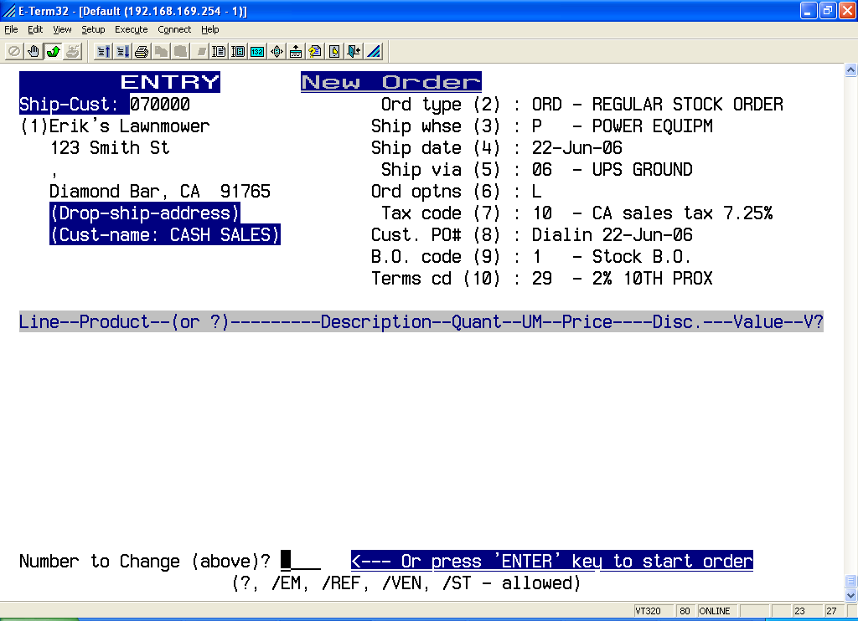

At the number to change prompt, you may alter the following fields in the order header by typing the field number and <Enter>:

- (1) Ship to (for shipping the order to a different location)
- (3) Shipping point (for shipping the order from a different location)
- (4) Ship date (for shipping the order on a different date)
- (5) Shipping method (for shipping the order a different way)
- (8) Purchase order number (for shipping the order using a specific P.O.)
- (9) Backorder type (for special handling of backordered items)

Please note that some fields may or may not be altered depending upon customer status.

Once you have made the necessary changes in the header press <Enter>.

Your screen will now look like this:

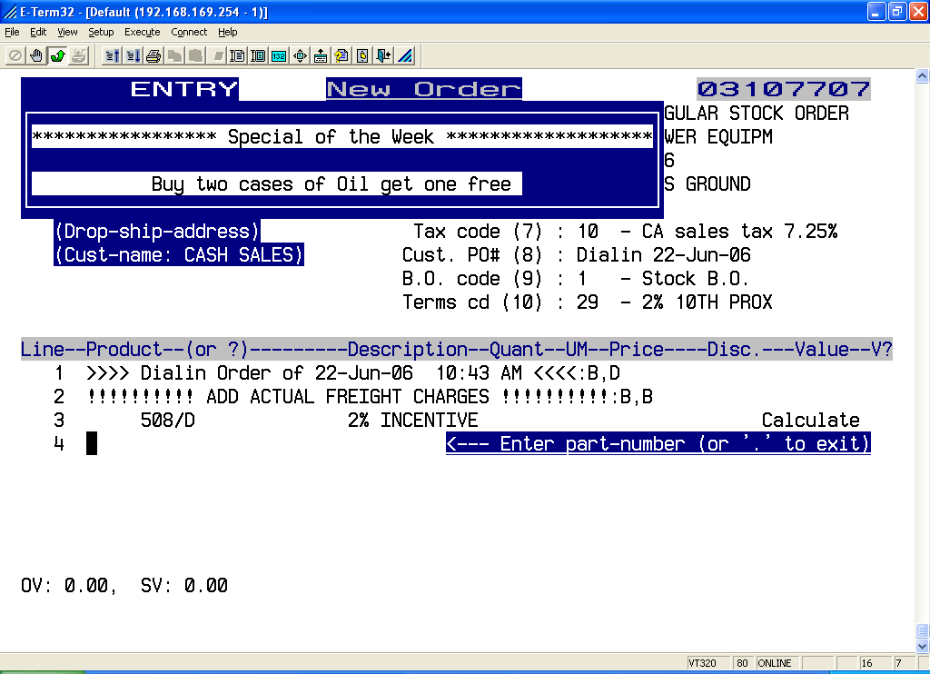

You may now enter the part number (example: 491588S) and press <Enter>.
If there is more than one manufacturer with the same part number, a list of part numbers is displayed and you may select the one you want by typing the line number of the correct part <Enter>.

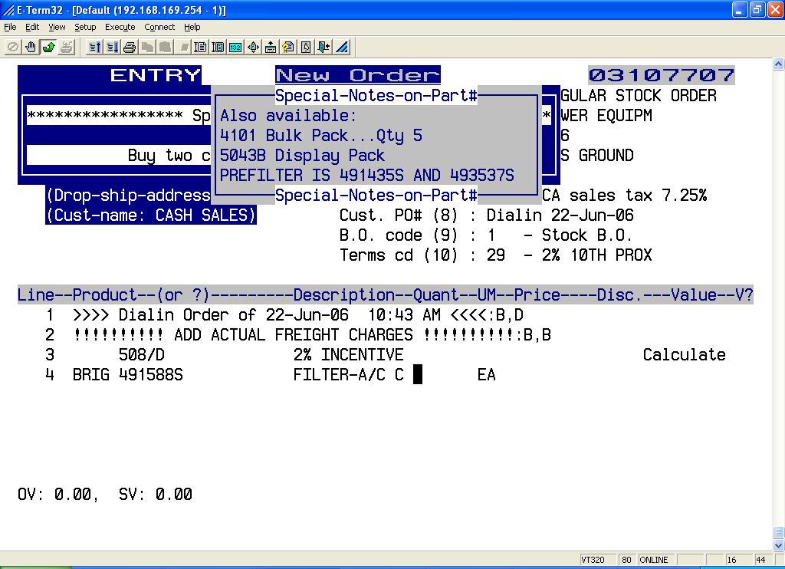

Now enter the quantity you want (example: 10) and press <Enter>.

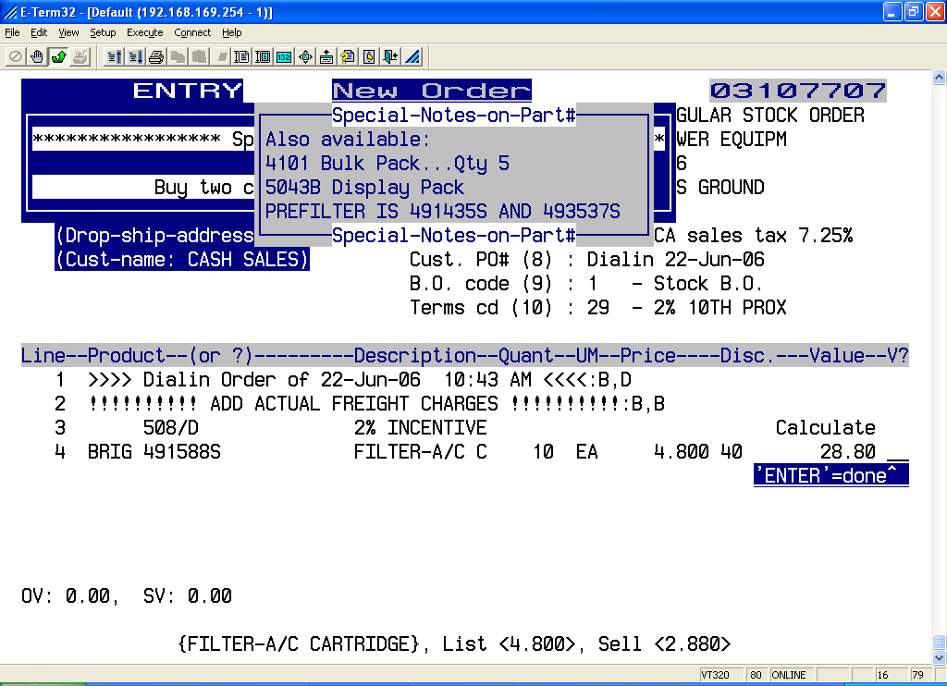

The cursor is now at a V ? prompt. Here you verify the accuracy of the part number and quantity you have entered. If you have made a mistake, type 0 <Enter> and the line will be cancelled and you may re-key the correct part number and quantity. If the part number and quantity are correct then press <Enter>.

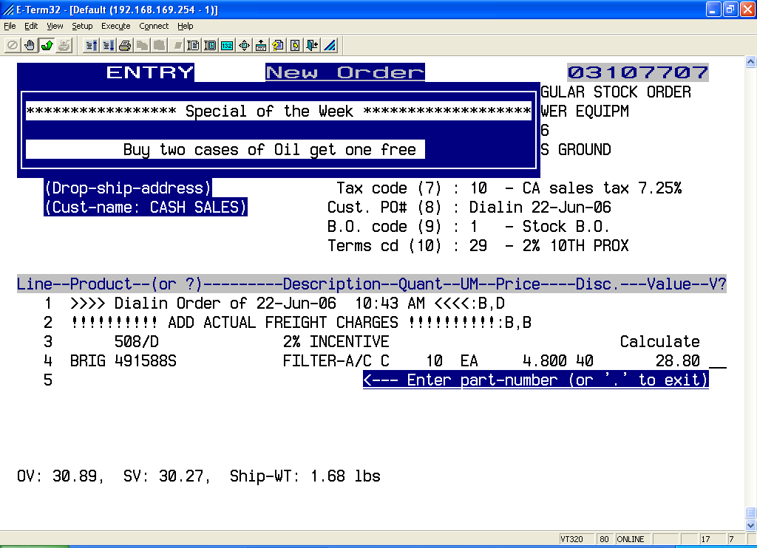

You may now enter the remaining items in the same way.

When you have entered the last part number and quantity type \ <Enter>.

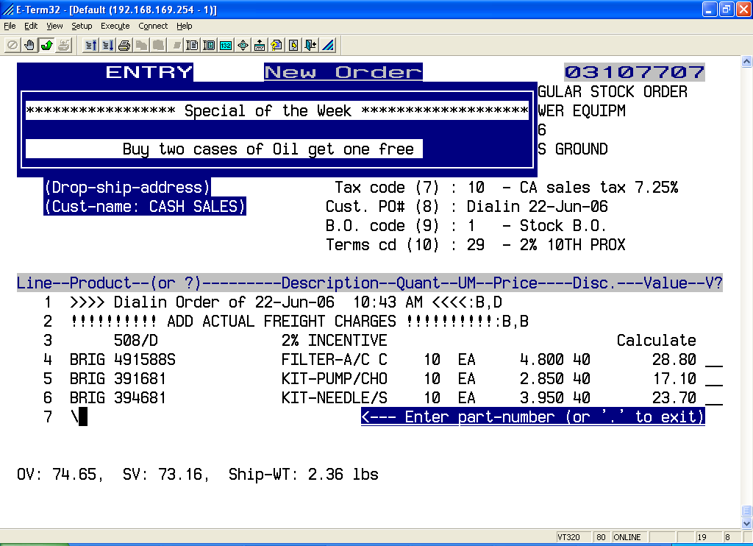

At this point, you may finish or return to any part of the order to add or make changes.

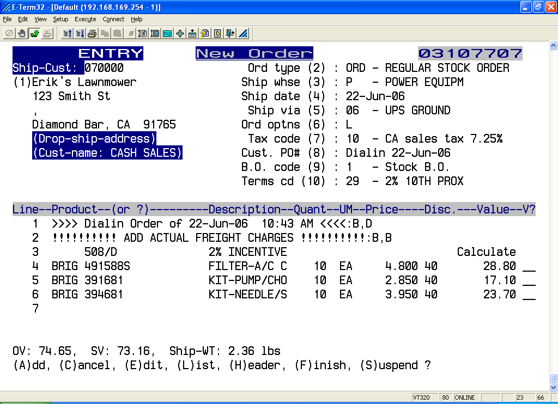

- A Type A <Enter> and add more part numbers to the order.
- C Type C <Enter> and cancel the entire order.
- E Type E <Enter> and cancel a particular part number on the order.
- L Type L <Enter> and display (scroll) through the entire order.
- H Type H <Enter> and return to the order header to make changes.
- F Type F <Enter> and finish the order.
- S Type S <Enter> and suspended the order for later completion.

RESTARTING AN ORDER

Select Restart Suspended/Pending Order (option # 2 from the Dialin Order Functions menu).

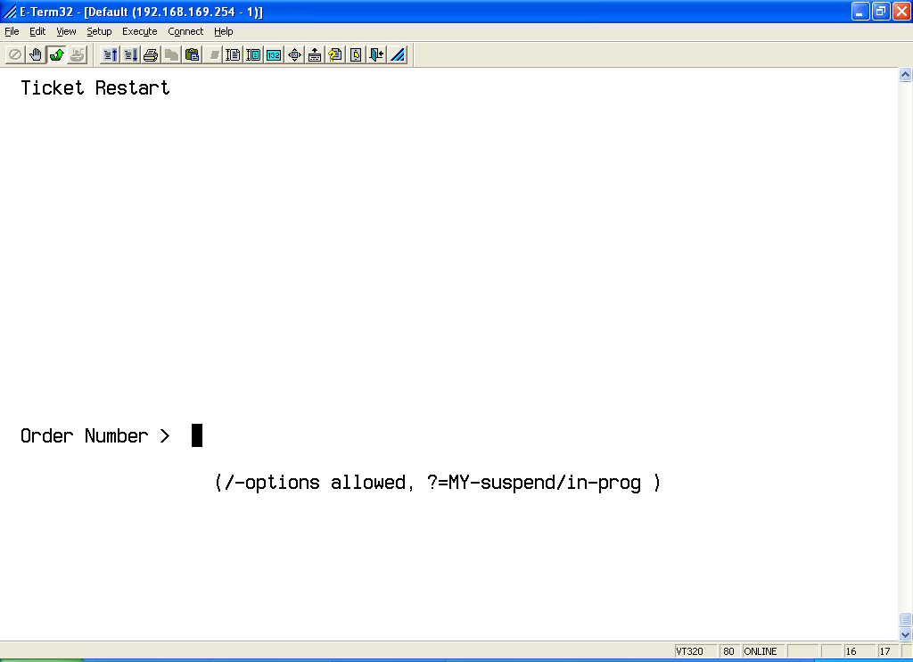

At the order number prompt, type the order number <Enter>. If you don’t know the order number type ? <Enter> and any suspended orders will be displayed.

If you have more then one suspended order then select the order number you want by typing the line number <Enter>. The order will be restarted and the cursor will return to the next part number line on the order.
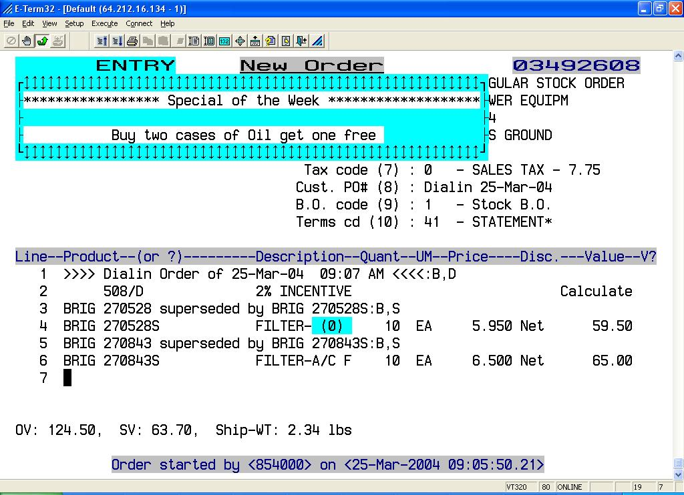

You may add more items, remove existing items, finish, cancel or suspended the order again.
BACKORDER INQUIRY

Select Backorder Inquiry (option # 3 from the Dialin Entry Functions menu).

You may inquire on backorders by manufacturer or part number.

To display all backorders press <Enter> <Enter> and all backorders will be displayed.

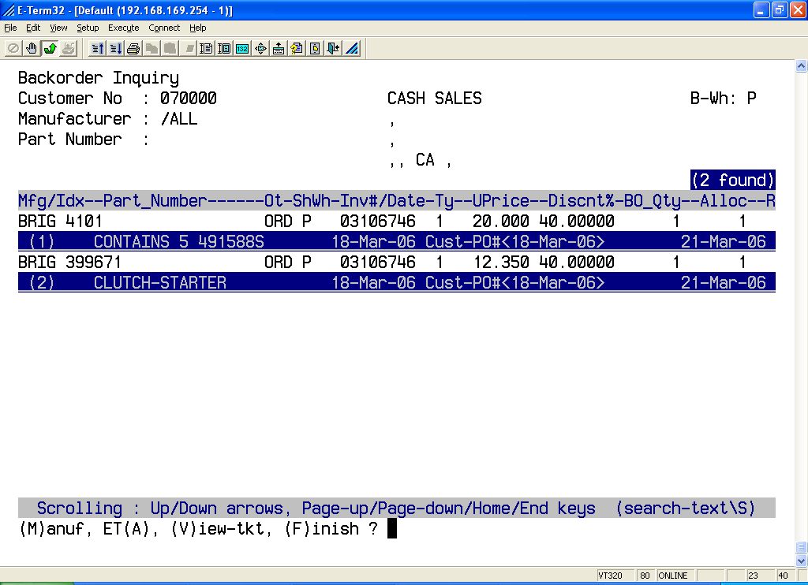

Backorders show original order/invoice number, purchase order number, the date and shipping warehouse as well as backorder type and quantity.

An explanation of backorder type is as follows:

- Type 1 Stock backorder
- Type 3 Emergency order through the shipping warehouse
- Type 4 Emergency order drop ship to customer

When an item has not become available then option “A” allows you to display an ETA for the selected item. After the inquiry, type M <Enter> to select another manufacturer or type F <Enter> to return to the Dialin Entry Functions menu.

CHECKING PRICE AND AVAILABILITY

Select Product / Stock Inquiry (option # 4 from the Dialin Entry Functions menu).

At the stock number prompt, type the part number (example: 491588S) <Enter> and the following screen will appear:

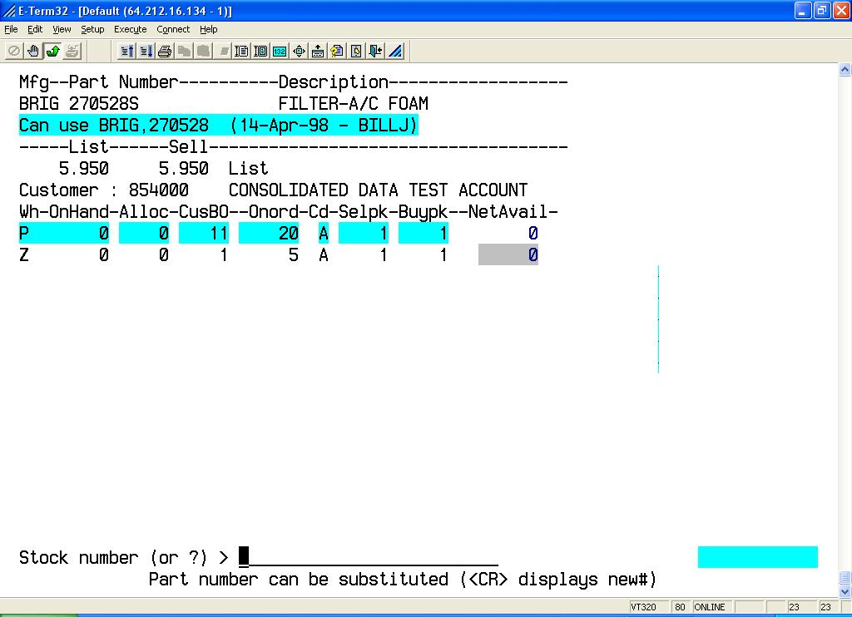

The screen will display the following information:

- Manufacturer, part umber, and description (example: BS 270528 Element, Air)
- List price (example: 8.75)
- Your cost (example: 3.39)
- Price level or discount (example: Dealer)
- Your customer number and name
- Warehouse location, quantity on hand, quantity allocated, quantity on backorder to all customers, quantity on order by warehouse, and the quantity available.

Each warehouse location represents a separate shipping point.

You may type another part number or \ <Enter> to return to the Dialin Entry Functions menu.
INQUIRING / LISTING A PREVIOUS ORDER

Select Order Inquiry / List (option # 5 from the Dialin Entry Functions menu).

You may inquire on / list your orders based on any / any combination of the following criteria:

- By order number
- By your purchase order number
- By your order date (example: 010598 = Jan 5, 1998)
- By our date shipped (example: 010598 = Jan 5, 1998)
- By the shipping warehouse (example: 01 = Cocoa, 11 = Diamond Bar)
- By order status (example: open orders, invoiced orders, credit memos, etc.)
- By the month (example: Jan = January, Dec = December)

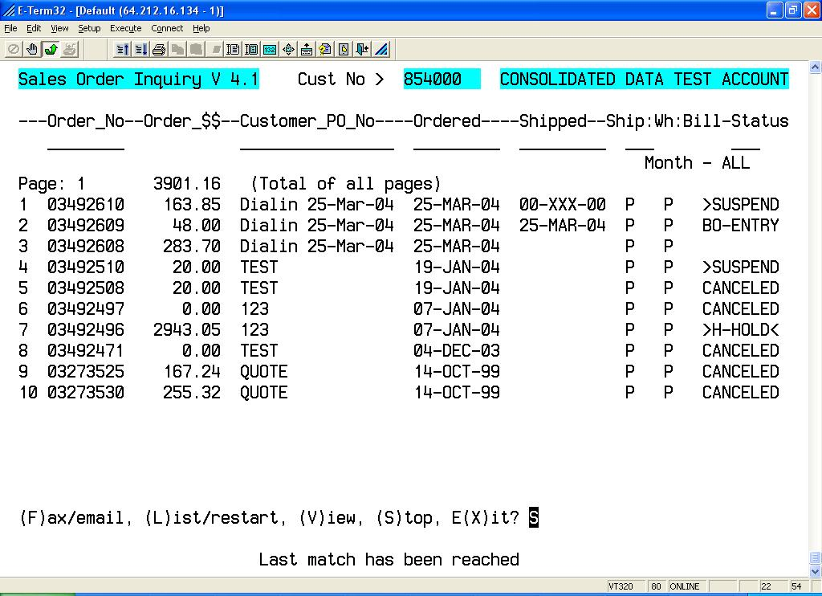
Select the appropriate option:

- L Shows you the lines on an order
- V Allows you to view an order
- S Allows you to stop and inquire on other orders
- X Exits to main menu

ENTERING A BACKORDER DIRECTLY

Select Backorder Entry (option # 6 from the Dialin Entry Functions menu). This option may not be available to all customers.

Your screen will look like this:

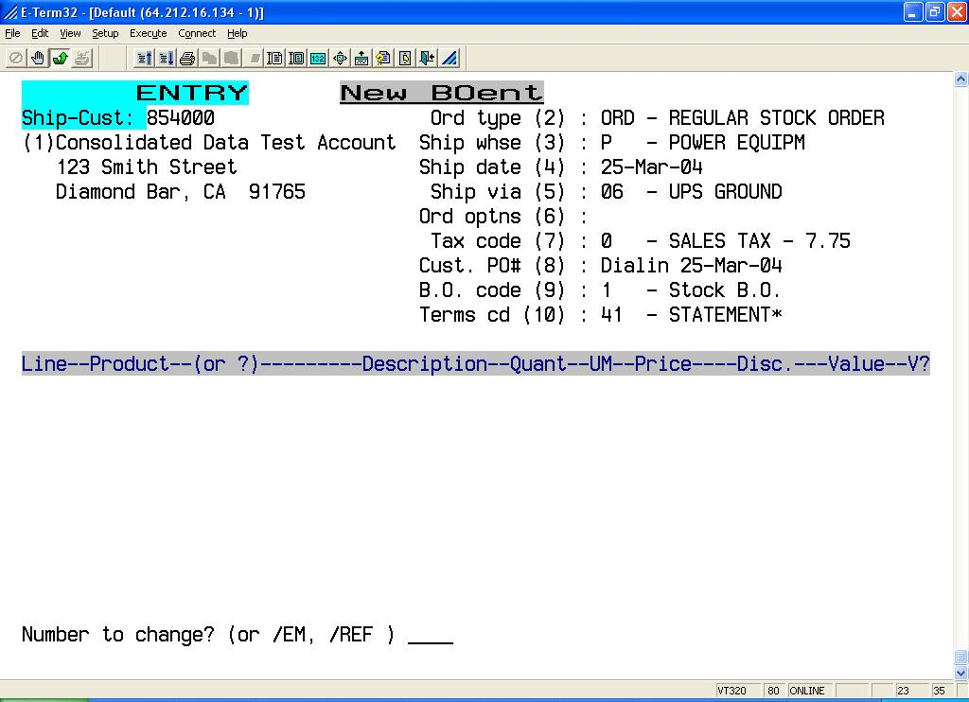

At the number to change prompt, you can change the following fields in the order header by typing the field number and <Enter>:

- (1) Ship to (to have the order shipped to a different address)
- (3) Shipping point (to have the order shipped from a different location)
- (4) Ship date (to have the order shipped on a different date)
- (5) Shipping method (to change the shipping instructions)
- (8) Purchase order number (to enter your P.O. number)
- (9) Backorder type (to change the backorder instructions)

Please note that some fields may or may not be changed depending upon customer status.

Once you have changed all the necessary header fields press <Enter>.

Your screen will look like this:

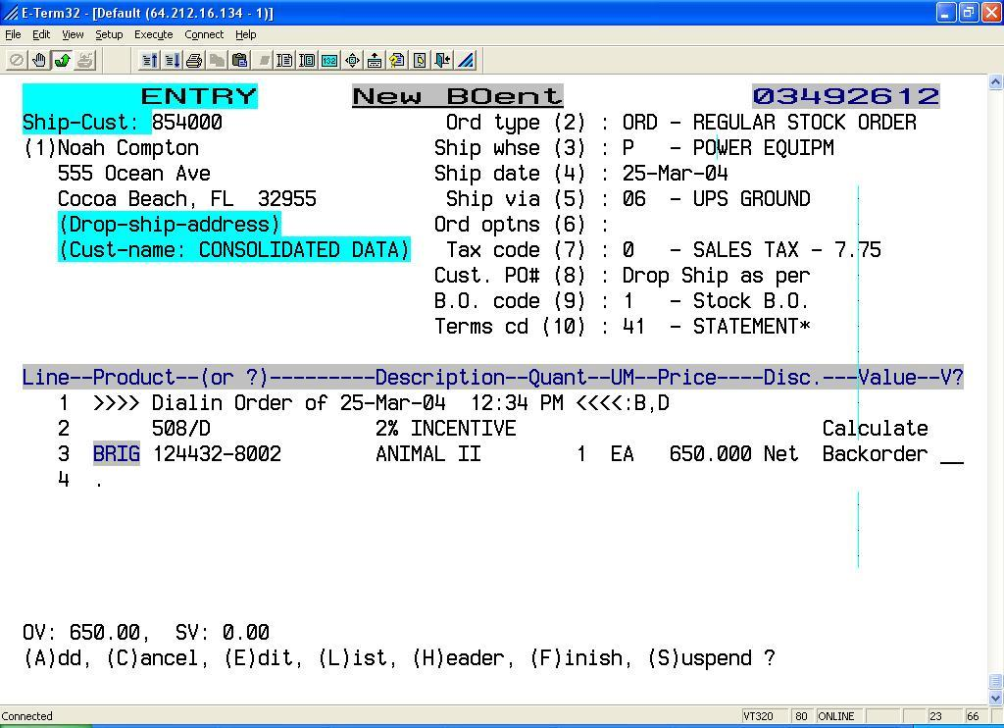

You may now enter the part number (example: 270528) and press <Enter>.
If there is more than one manufacturer with the part number, a list of the part numbers is displayed and you may select the one you want by typing the line number of the correct part <Enter>. Now enter the quantity you want (example: 10) and press <Enter>.

Your cursor will now be at a V ? prompt. This is where you verify the accuracy of the part number and quantity you have entered. If you have made a mistake, type 0 <Enter> and the entire line will be cancelled and your may re-key the correct part number and quantity. If the part number and quantity are correct then merely press <Enter>.
You may now enter the remaining items in the same way.

When you have entered the last part number and quantity type \ <Enter>.

Your screen will look like this:

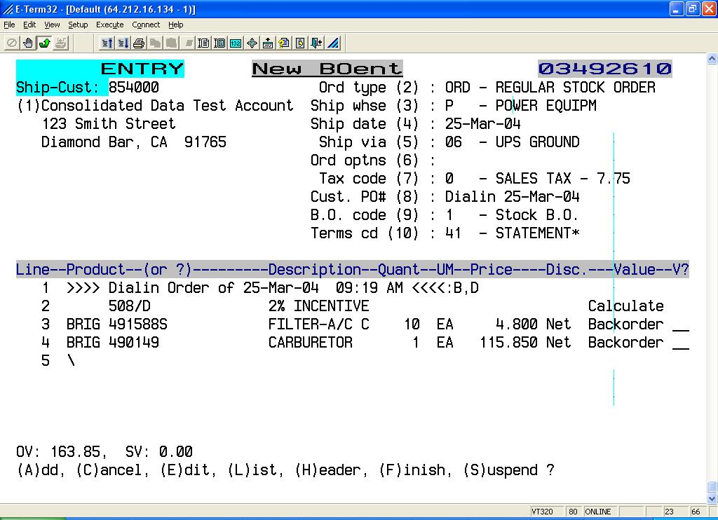

At this point, you may finish or return to any part of the backorder entry to add or make changes.

- A Type A <Enter> and add more part numbers to the order.
- C Type C <Enter> and cancel the entire order.
- E Type E <Enter> and cancel a particular part number on the order.
- L Type L <Enter> and display (scroll) through the entire order.
- H Type H <Enter> and return to the order header to make changes.
- F Type F <Enter> and finish the order.
- S Type S <Enter> and suspend the order for finishing at a later time

